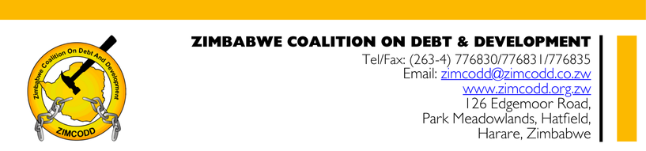
PRESS STATEMENT
FOR IMMEDIATE RELEASE
ZIMCODD Urges Comprehensive Policy Overhaul to Tackle Zimbabwe’s Maternal Mortality Emergency
Harare, 17 April 2025 — The Zimbabwe Coalition on Debt and Development (ZIMCODD) issues this statement in response to the distressing maternal mortality figures reported by the Daily News on 17 April 2025. As an organization advocating for equitable resource governance, ZIMCODD underscores the urgent need to address systemic failures in healthcare delivery, which disproportionately affect women in rural and low-income communities.
Analysis of the Crisis
Zimbabwe’s maternal mortality rate—estimated at 462 deaths per 100,000 live births (ZDHS 2015)—is a stark indicator of entrenched inequities. While the government’s National Health Strategy (2021–2025) and partnerships with global agencies like UNICEF have yielded incremental progress, structural gaps persist:
- Chronic Underfunding of Healthcare
  - Despite constitutional obligations (Section 76), healthcare receives only 10.2% of the 2025 national budget, falling short of the 15% Abuja Declaration target. Rural clinics, which serve over 60% of the population, operate with erratic drug supplies, obsolete equipment, and severe staff shortages (1 nurse per 1,500 patients in Matabeleland North, per MoHCC 2023).
  - Policy Gap: Austerity measures and debt servicing (allocating 18% of revenue to debt in 2024) divert critical funds from health. Without prioritizing health in fiscal policies, maternal deaths will remain unaddressed.
- Poverty and Geographic Marginalization
  - Over 70% of Zimbabweans rely on informal livelihoods, limiting their ability to pay for healthcare. Indirect costs (transport, supplies) force many women to delay or forgo antenatal care. In provinces like Masvingo, maternal waiting homes are underutilized due to unaffordable user fees.
  - Policy Gap: The absence of universal health coverage (UHC) frameworks leaves vulnerable women exposed. Existing social protection programs, like the Harmonized Social Cash Transfer, lack explicit maternal health targeting.
- Gender Inequality and Silenced Voice
  - Patriarchal norms restrict women’s autonomy over healthcare decisions, while 1 in 3 girls marries before 18 (UNICEF, 2023), heightening pregnancy risks. Youth-friendly sexual and reproductive health (SRHR) education remains inconsistent, particularly in rural schools.

Evidence-Based Policy Recommendations
ZIMCODD proposes the following actionable measures to align Zimbabwe’s policies with its constitutional and SDG 3.1 commitments:
- Fiscal Justice for Healthcare
  - Immediate Action: Reallocate funds from non-essential expenditures (e.g., luxury government vehicles) to meet the Abuja target by 2025.
  - Long-Term Reform: Introduce a progressive health levy (e.g., 2% tax on mining revenues) to finance rural maternal clinics and emergency obstetric care. Also timely disburse resources generated from sugar tax to hospitals.
- Pro-Poor Maternal Health Safeguards
  - Expand the Harmonized Social Cash Transfer to include a Maternal Health Grant (USD $15/month) for pregnant women in poverty hotspots.
  - Eliminate user fees for maternal services in public facilities, modeled on Malawi’s successful fee-waiver system.
- Decentralized and Community-Led Solutions
  - Scale up training for Community Health Workers (CHWs) in emergency obstetric care, leveraging lessons from Manicaland’s CHW pilot (60% reduction in delivery complications in 2022).
  - Partner with traditional leaders to promote facility-based deliveries while respecting cultural practices.
- Accountability and Transparency
  - Mandate quarterly parliamentary audits of health sector spending (revenue – generated from sugar tax), with civil society oversight.
  - Establish a National Maternal Mortality Review Board to document and publicize preventable deaths, ensuring data-driven policymaking.

A Call to Action
“Zimbabwe cannot achieve sustainable development while women die from preventable causes,” said Mr. John P Maketo, ZIMCODD’s Executive Director. “We urge the government to treat maternal health as a macroeconomic priority—investing in women’s health is investing in national productivity. Let us collaborate across sectors to dismantle the barriers of poverty, gender inequality, and geographic neglect.”

End

